MACH4METAL

metalworking machinery
Transito 21
6909 DA BABBERICH Netherlands
Tel. +31 (0)316-247123
Fax: +31 (0)316-247956
info@mach4metal.com

Bank No : 66.52.13.883
IBAN : NL33 INGB 0665 2138 83
BIC : INGBNL2A

HEDELIUS CB 60 3250 x 650
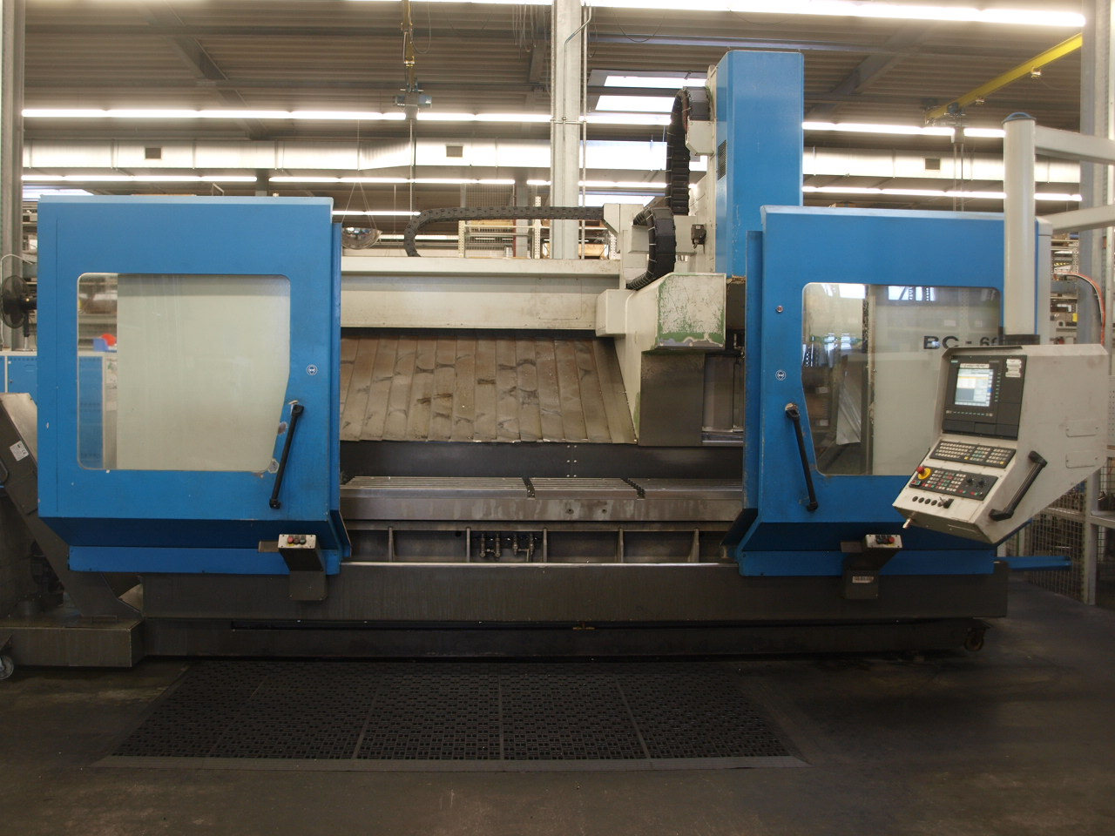
- Make : Hedelius Germany
- Typ : CB 60
- No. : 061117
- Age : 1997

- X Travel : 2.500
- Y Travel : 630
- Z Travel : 700

- Table length : 3.250
- Table width : 650
- Table load : 3.300
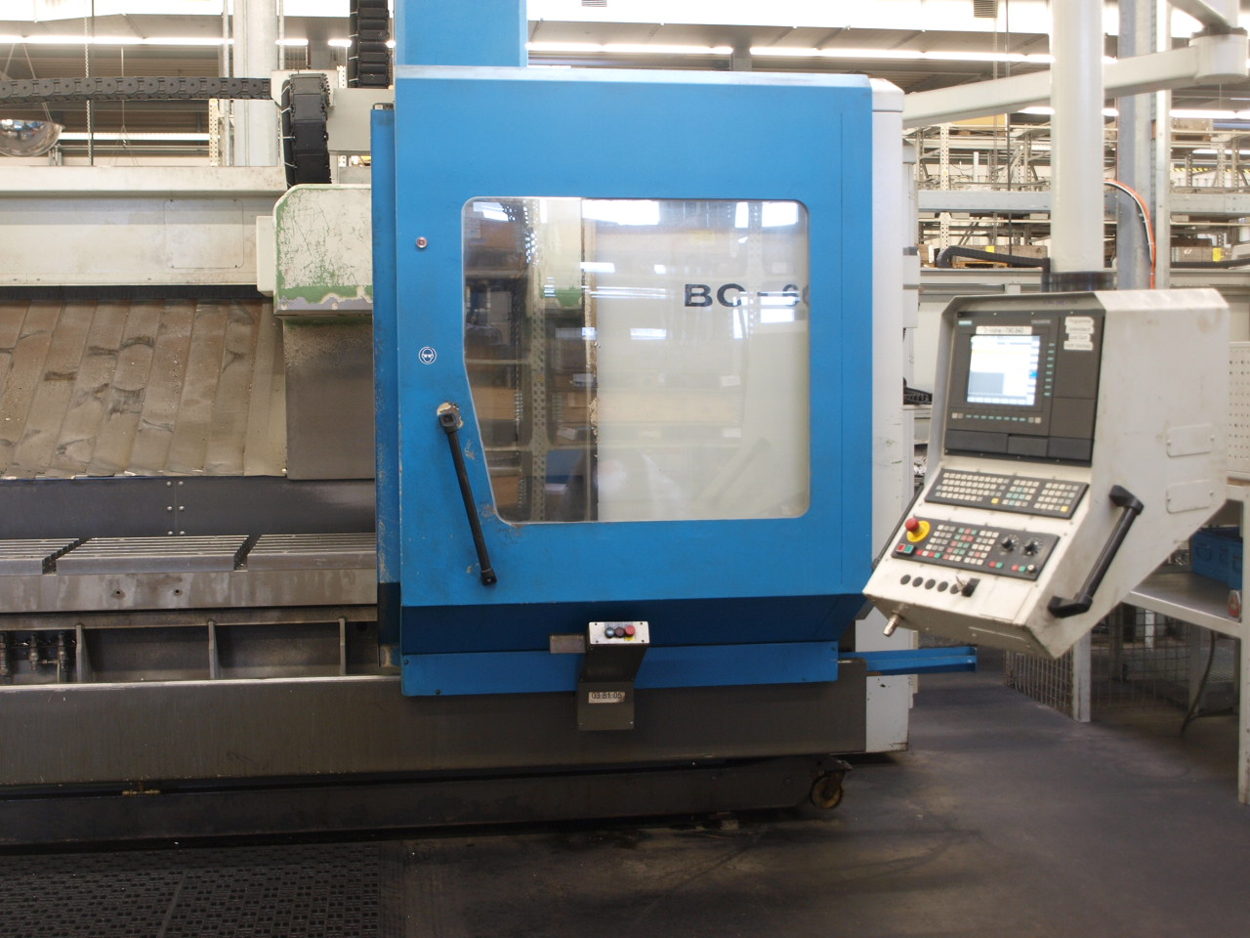

- Spindle : BT 50
- Speeds : 5000 Rpm
- ATC : 30 Positions
- Rapid feed : 0.000 mm/M

- Dimensions
- Length : 7.500
- Width : 3.500
- Height : 3.600
- Weight : 14.000 Kg
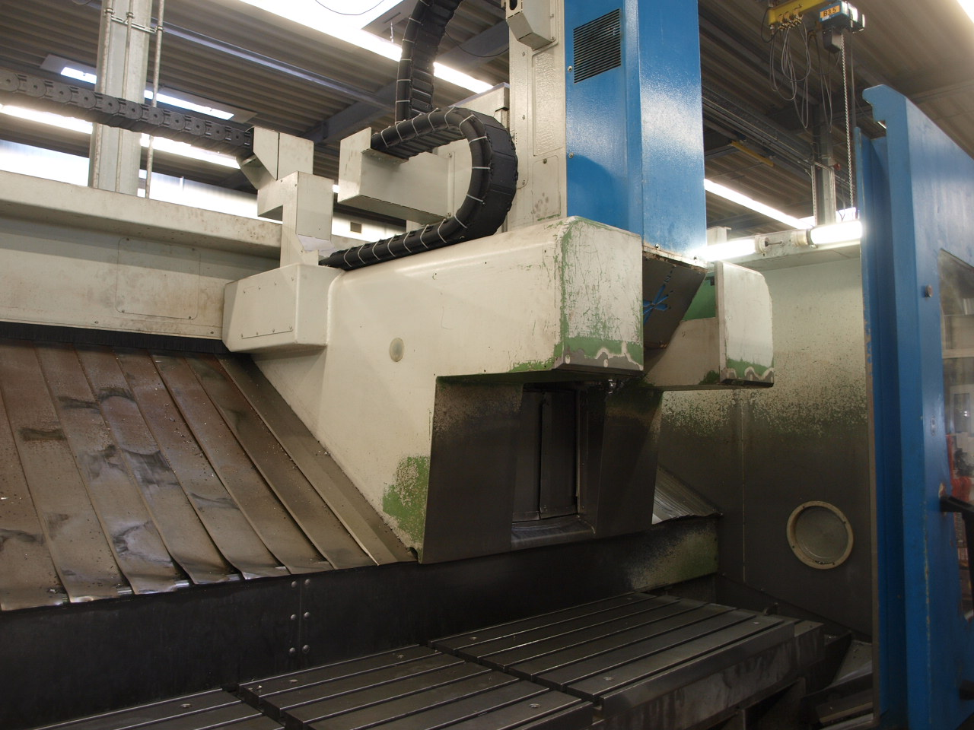
- Power : 44 kW

- SIEMENS 840 D
- Good running condition
- Chip conveyor
- High pressure coolant

Please Note: The above information has been obtained to the best of our ability and belief from, and from the manufacturers where possible. It is given in good faith, but its accuracy can not be guaranteed. Accordingly, it will not form a representation or constitute contractual terms. We advise you to check any vital details!

